

pacman

GDD CA1



March 14, 2019

Ceiran mccabe

X00132492

PACMAN

Contents

Introduction 1

Pacman Rules 1

Development 3

Improvements 4

# Introduction

I have decided to attempt to recreate Pacman for my Year 4 Game Design and Development Assignment 1.

Having been an arcade enthusiast in my younger days, albeit towards the end of the era, I was obsessed with Pacman. So, to learn the processes of how it was made and try applying them myself was really exciting.

# Pacman Rules

(Taken from http://www.pacxon.net/pacman-rules.php )

There can't be many people in the western world who haven't heard of the iconic Pacman game. Originally created in 1980 the concept was straightforward.

Let's break it down as follows:

Pacman

Little yellow pellets

Ghosts

That can't possibly be it - how and why would Pacman, the Boss of the Operation, spend his time chasing little yellow pellets around the playing area.

Of course, let's not forget the third element - Ghosts! Well, of course, every self-respecting game must have Ghosts, so in they go!

Simple Concept

The most successful games are easily understandable and draw people in because they feel they can play without looking stupid. The principle of Pacman is similar in that it is a simple game which players want to try, and feel because it is so straightforward they have a realistic chance of winning. In the early days, video games were a new and largely untested idea with no-one anticipating the huge demand.

At the top of this piece, there were three points made about the simplicity of the game. Because on first glance this is what any gamer may see, they are sure that they will be able to conquer the game without any difficulty. In fact, they may even decide that it won't challenge them at all.

Let's revert to the basic game plan. Yes, Pacman is a happy, yellow character who wants to get out of the playing area - called a room. In order to do this our cheeky chappie needs to "eat" all of the little yellow pellets - correct name, pellets, whilst avoiding the monsters, which are now called Ghosts. They all have their own names - Inky, Pinky, Blinky and Clyde are the names they begin with - but more about that later! There is a skill level which must be achieved to progress further and if Pacman touches a Ghost then one of Pacman's three lives will be lost.

There are different levels of the game, so the first playing area isn't where the game finishes - unless you are really bad and don't make it past this first room.

Brief Game Rules

To further explain the rules let's break it down as follows:

Pacman, our hero, munches his way around the room, eating all of the pellets.

In each corner of the room there is a "Super Pellet", which when Pacman eats one, the Ghosts turn blue or yellow. Pacman can get extra points by eating the Ghosts. The first one is worth 200 points and each additional Ghost eaten is worth double the number of points.

# Development

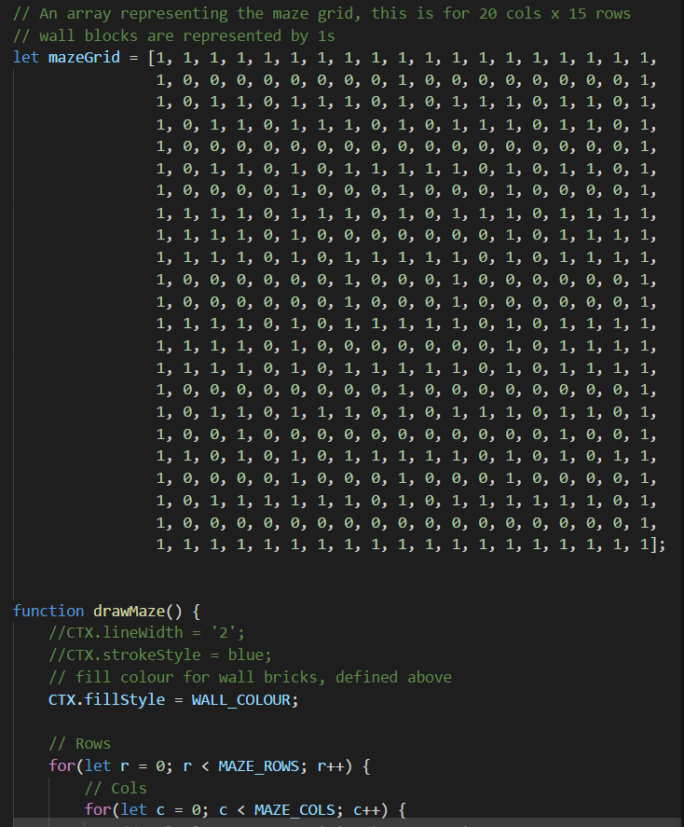With the excitement, I rushed into the development and created a Pacman maze based on the canvas maze to get the idea of how I would draw the map. Although this was not necessary, I found it useful preparation.

The next step I took was searching online for useful sprites to use in my game. There are a lot of different sprites and sprite sheets online for Pacman but most of which I found to be useless or unusable.

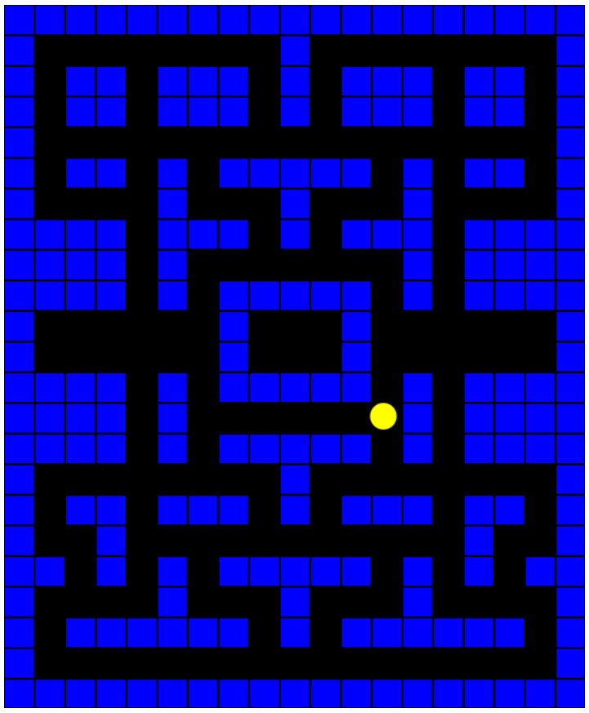Once I located appropriate sprites it was time to set up my environment. I decided to use node.js to act as a web server to host my game once it was up and running. The method and file for this approach was sourced from our lecturer Enda’s git repo: <https://github.com/elee-ittdublin/phaser3_intro>

I next used tutorials from https://phaser.io/tutorials/making-your-first-phaser-3-game to achieve more of an understanding of the steps and process required to deliver a fully functioning game in phaser 3 which is what I will be using for my Pacman game.

When I got through all the steps in the tutorial it was time to get stuck into the real thing. I downloaded tiled map editor and started drawing the pacmap. I decided to draw the map from scratch as opposed to inserting bit by bit from a tileset because the tilesets weren’t great and I felt I could do a better job adding to the map layer by layer manually. It took me a bit of time to get used to tiled and how to effectively and efficiently used the layers. The only way to get used to it was trial and error.

I have four tiled layers for the pacamp the first/bottom layer is just a blank back background on top of this I have a layer called walls. This layer shows the boundaries that Pacman will be confined to and will be set as collision boundaries for the world/environment he lives in. The next layers are pellets and super pellets respectively. This is the objective of the game, for Pacman to stay alive long enough for him to eat all the pellets.

I later found out the hard way when I had finished creating the map that once it was loaded on the web browser it was 6 times too big to fit on the page. Reluctantly after spending hours in tiled creating the map it was back to the drawing board and starting again.

I used the following slide sheet tutorial that Enda made available which helped with tiled and using the tiled components and importing them into the game <https://ittd.sharepoint.com/:w:/r/sites/computing-course-content/_layouts/15/Doc.aspx?sourcedoc=%7Be38fe901-38e8-4605-86ef-a410a4448c90%7D&action=default&gad=421> .

When I finally finished pacmap 2.0 in tiled and ensured the layers were correct and the map fitted on the page, it was time to start inserting the sprites and get them moving. I used the following two links and the previous link to get my Pacman sprite outputted in the game, moving around and collecting the pellets which increases his score.

<https://gamedevacademy.org/how-to-create-a-turn-based-rpg-game-in-phaser-3-part-1/>

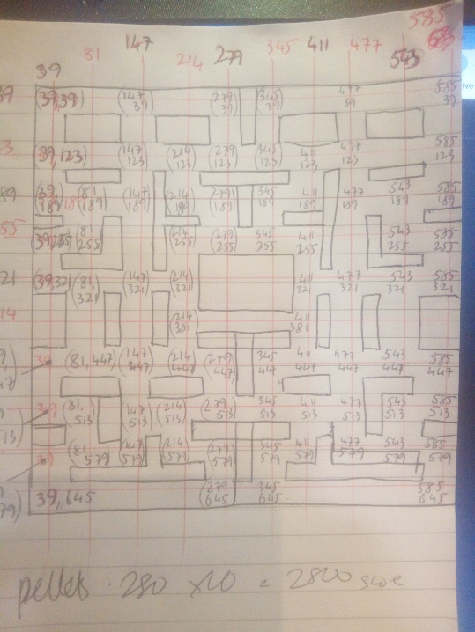<https://gamedevacademy.org/how-to-create-a-turn-based-rpg-game-in-phaser-3-part-2/>

To create the enemies/ghost I used similar logic I used to create the Pacman however as they have to move around without control, I used the following link to spawn them and have them move around the map on a path. In order to cover the whole map took a long time to figure out the coordinates and map each of them down. I ended up with over 100 points on my path.

<https://gamedevacademy.org/how-to-make-tower-defense-game-with-phaser-3/>

# Improvements

2 player – An interesting feature would be to integrate a 2 player mode where the second player could play are an ally or as an enemy.

Extra support – the introduction of an AI ally would be an interesting addition. If you are down to one life remaining and you eat a super pellet and an ally appears for 10 sec for example.

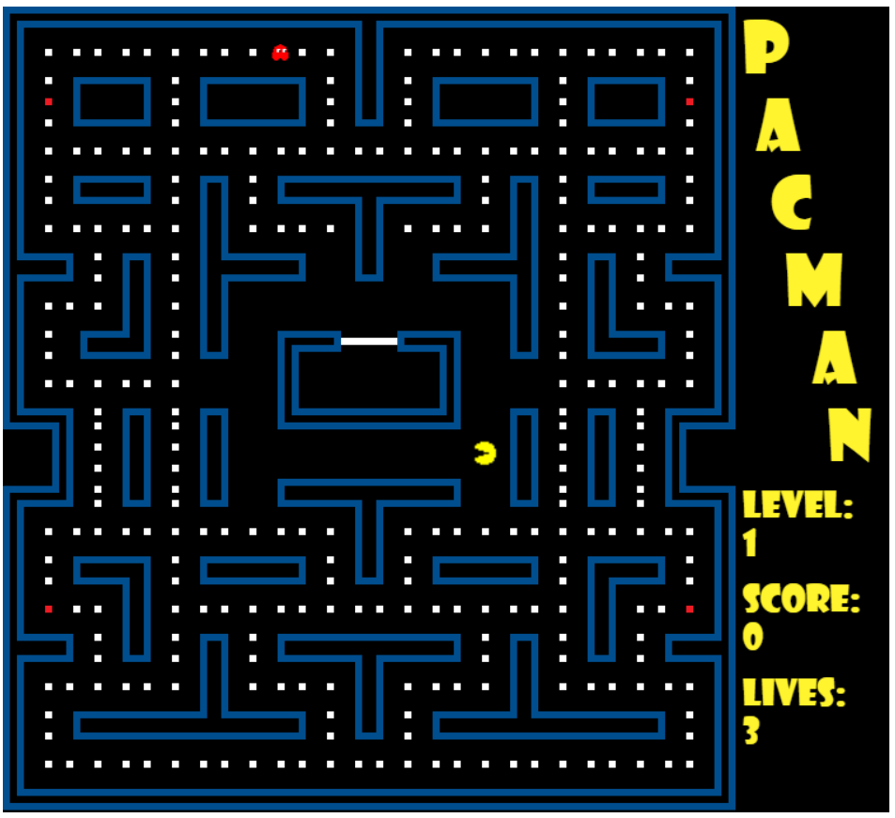Collison with enemies – I was unable to get enemies to collide with Pacman and take one of his lives. I tried several different ways and methods and resources for colliding with an enemy on a path were extremely hard to find. I feel I was close to completing this step and feel it is the only feature I have failed to achieve.